Cosmos Dedup Architecture
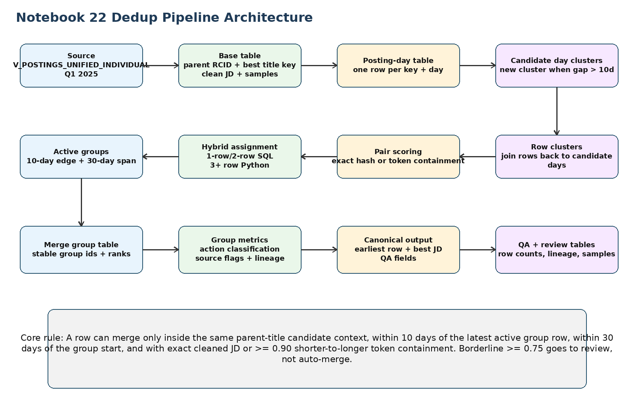
Figure 1. End-to-end pipeline architecture.

1. Recommended Message to Data Engineering
This notebook implements the Q1 2025 parent-title dedup pipeline. It first creates candidate windows using ULTIMATE_PARENT_RCID + COALESCE(TITLE_TRANSLATED, TITLE_RAW), then applies date guardrails and JD similarity rules before writing a lineage-preserving canonical table.
The automatic merge decision is intentionally conservative: rows merge only when cleaned JD is identical or shorter-to-longer token containment is at least 0.90. Rows with borderline similarity or skipped large diagnostics are kept for review rather than silently merged.
The notebook also contains an optional JD translation code block. Translation is post-canonical only and is disabled by default in Cell 3 through ENABLE_CANONICAL_TRANSLATION = FALSE. If the team wants translated JDs, set the flag to TRUE in Cell 3 and run Cell 17 / SQL Cell 9D: Optional post-canonical translation enrichment after the canonical table is created. Cell 16 is only an audit to estimate likely non-English volume and does not call Cortex.
-- Cell 3: default setting
SET ENABLE_CANONICAL_TRANSLATION = FALSE;
-- To enable translation after cost/business approval:
SET ENABLE_CANONICAL_TRANSLATION = TRUE;
-- Then run Cell 17 / SQL Cell 9D.

2. Scope, Output, and Key Parameters
Item | Value
Source table | H_EDW.HS_REVELIO_EDW_V.V_POSTINGS_UNIFIED_INDIVIDUAL
Date scope | POST_DATE >= 2025-01-01 and POST_DATE < 2025-04-01
Candidate key | MD5(ULTIMATE_PARENT_RCID | COALESCE(TITLE_TRANSLATED, TITLE_RAW))
Final canonical table | PC_FIVETRAN_DB.DA_WORKSPACE.COSMOS_DEDUP_Q1_2025_CANONICAL_OUTPUT_UPRCID_TITLETR_TC_GROUP_REP_10D
Optional translation table | PC_FIVETRAN_DB.DA_WORKSPACE.COSMOS_DEDUP_Q1_2025_CANONICAL_TRANSLATION_UPRCID_TITLETR_10D
Candidate-day gap | 10 days
Final merge edge gap | 10 days
Final max merge-group span | 30 days
Auto-merge threshold | TOKEN_CONTAINMENT_MERGE = 0.90
Review threshold | TOKEN_CONTAINMENT_REVIEW = 0.75
Shorter-side sample | Full text when <= 3,500 chars; otherwise stratified 3,500 chars
Longer-side text | Full cleaned JD

3. Architecture Overview
The pipeline is divided into separate layers. The candidate cluster is a broad search space, while the merge group is the final dedupe result. This separation prevents missed duplicates while still keeping final merges conservative.
Figure 2. End-to-end architecture from source parameters to final canonical output.

4. Core Logic in Depth

4.1 Candidate key and base table
The base table keeps all original source columns using p.* and adds dedupe helper fields. The candidate key uses parent company and best available title. TITLE_TRANSLATED is preferred when present; TITLE_RAW is used as fallback.
RAW_MATCH_KEY = MD5(
COALESCE(ULTIMATE_PARENT_RCID, '<<NULL_ULTIMATE_PARENT_RCID>>') || '|' ||
COALESCE(NULLIF(TITLE_TRANSLATED, ''), NULLIF(TITLE_RAW, ''), '<<NULL_TITLE>>')
)
The base filter keeps Q1 rows with POST_DATE, COMPANY, and at least one non-blank title field. Since ULTIMATE_PARENT_RCID is part of the candidate key but is not filtered as mandatory in the notebook, null parent-RCID handling should be finalized before productionizing.

4.2 JD cleaning and scoring fields
DESCRIPTION is converted into CLEAN_DESCRIPTION by removing HTML tags, normalizing whitespace, trimming, and lower-casing. CLEAN_DESCRIPTION_HASH is used for exact JD matches. Token containment uses SHORTER_SAMPLE_TEXT against LONGER_SEARCH_TEXT.
- SHORTER_SAMPLE_TEXT uses the full cleaned JD when length is <= 3,500 characters.
- If the cleaned JD is longer than 3,500 characters, the shorter side uses a stratified sample: first 1,000 + 500 near 33% + 500 near 50% + 500 near 67% + last 1,000 characters.
- LONGER_SEARCH_TEXT keeps the full cleaned JD. There is no longer-side cap in the decision path.

4.3 Candidate clustering
Candidate clustering happens before JD scoring. It groups distinct posting days by RAW_MATCH_KEY and chains days when the gap from the prior posting day is <= 10 days. A new candidate cluster starts only when the gap from the previous posting day is > 10 days.
Same key posting days:
Jan 01 -> Jan 05 gap 4 => same candidate cluster
Jan 05 -> Jan 14 gap 9 => same candidate cluster
Jan 14 -> Jan 29 gap 15 => new candidate cluster
Important distinction: being in the same candidate cluster does not mean rows will merge. Candidate clusters only decide which rows are worth comparing.

4.4 Pair-level scoring
Pair scoring is calculated inside candidate contexts for manageable cluster sizes. It creates exact JD and token-containment diagnostics. Large pair-scoring contexts are skipped for stability and are later surfaced into review logic instead of being silently ignored.
TOKEN_CONTAINMENT_SCORE =
count(distinct shorter-side tokens also present in longer-side tokens)
/ count(distinct shorter-side tokens)
Condition | Meaning
CLEAN_DESCRIPTION_HASH is equal | Eligible for MERGE_EXACT_JD
Token containment >= 0.90 | Eligible for MERGE_TOKEN_CONTAINMENT_USE_BEST_JD
Token containment >= 0.75 and < 0.90 | Borderline; review context
Token containment < 0.75 | Related candidate exists but JD similarity is low
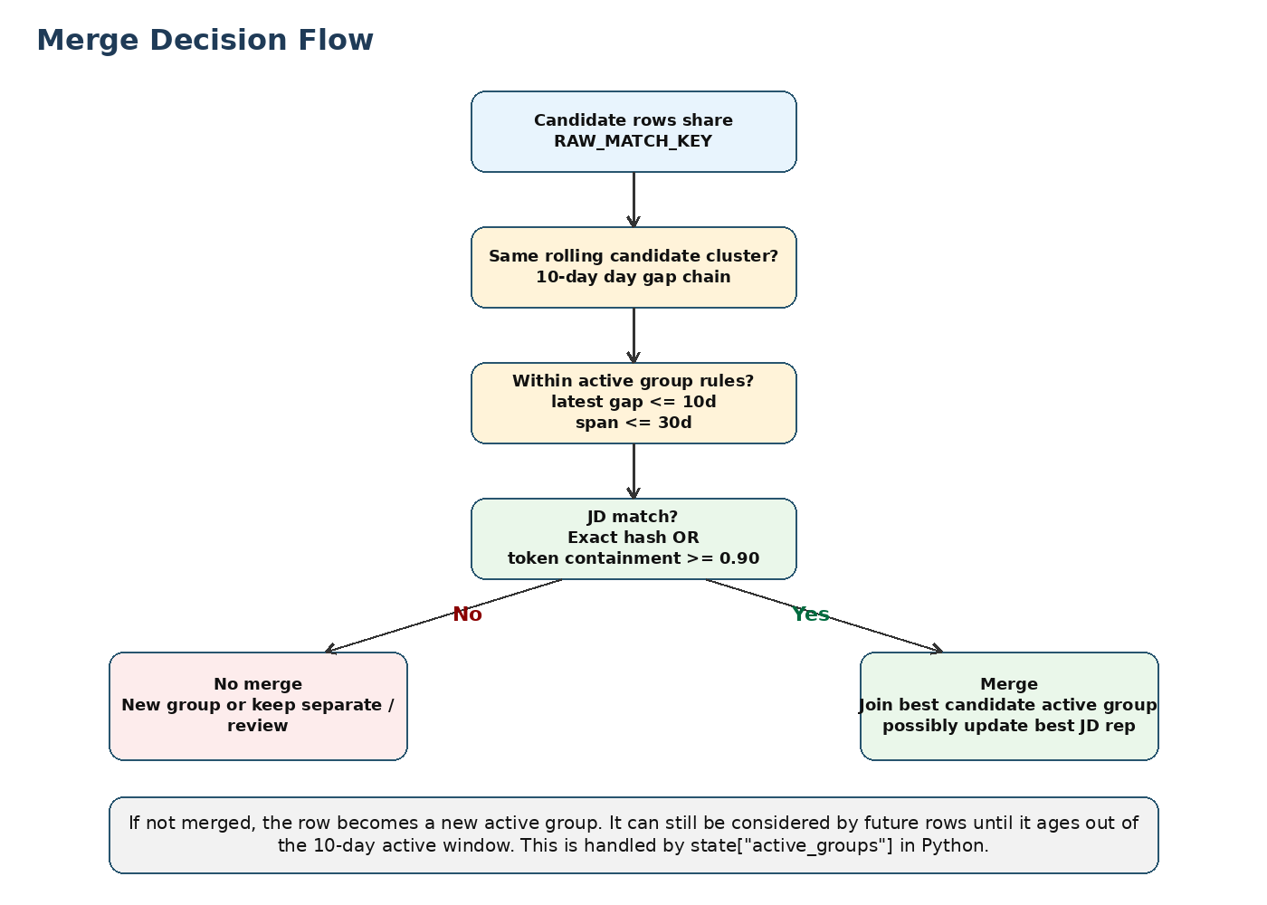
Figure 3. Merge decision flow: date gates plus JD similarity.

4.5 Hybrid SQL/Python assignment
The notebook routes clusters by size. SQL handles simple cases; Python handles 3+ row clusters because they need active group state.
Cluster type | Processing path | Logic
1-row cluster | SQL | No comparison exists. The row becomes GROUP_ROOT and usually ends as NOTHING.
2-row cluster | SQL | Only one pair exists. SQL checks pair eligibility plus 10-day edge and 30-day span.
3+ row cluster | Python | Rows are processed in date order. Each row checks active group representatives and either joins one group or starts a new group.
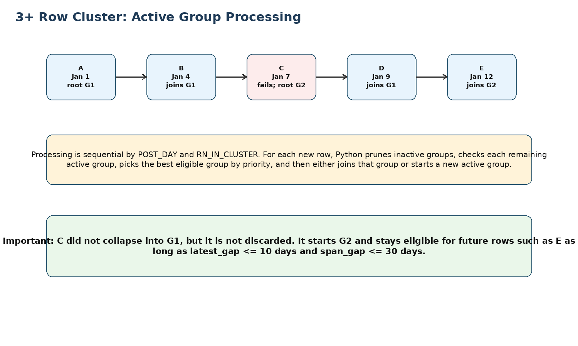
Figure 4. Active group handling for 3+ row clusters.

4.6 3+ active group algorithm
- Rows are processed by CLUSTER_ID and RN_IN_CLUSTER, where RN_IN_CLUSTER is ordered by POST_DAY and JOB_ID_STR.
- Before scoring a new row, active groups are pruned if current row date minus group latest day is more than 10 days.
- For each remaining active group, the row is rejected if joining would make the group span exceed 30 days.
- The row compares to the group representative using exact JD hash first, then token containment.
- If multiple groups match, the best group is selected by action priority, containment score, latest gap, span gap, and group sequence.
- If a valid match exists, the row joins that group and the group latest day is updated.
- If no valid match exists, the row starts a new active group. That new group can still accept future rows until it is pruned by the 10-day latest-gap rule or blocked by the 30-day span rule.

4.7 Best JD selection
When rows merge, the final canonical row uses the original non-helper columns from the earliest posted row, but the selected description/JD is chosen from the best available row in the merge group.
Priority | Criterion | Reason
1 | Longer CLEAN_DESCRIPTION | More complete JD content is preferred.
2 | No HTML tags | Cleaner text is preferred when length ties.
3 | Company-site source | Company-site JD is preferred when length and HTML status tie.
4 | Earlier post date | Stable business tie-breaker.
5 | Lower JOB_ID | Final deterministic tie-breaker.
Length has first priority. If one JD is longer but contains HTML and another is shorter but cleaner, the longer JD wins first; HTML matters only after length ties.

4.8 Final action classification
Action | Logic
MERGE_TOKEN_CONTAINMENT_USE_BEST_JD | Source record count > 1 and at least one token-containment join exists.
MERGE_EXACT_JD | Source record count > 1 and exact joins exist, with no token-containment join taking precedence.
NOTHING | Single source record and candidate cluster has only one job.
REVIEW_BUCKET | Singleton output where diagnostics were skipped or related token containment is >= 0.75.
KEEP_SEPARATE_MATERIAL_JD_CHANGE | Related candidate exists but JD similarity is materially low.
If a group contains both exact and token-containment joins, the group action is labelled MERGE_TOKEN_CONTAINMENT_USE_BEST_JD because that branch is evaluated first in the final CASE logic.

4.9 QA and lineage outputs
The notebook includes pre-final and final QA gates. Pre-final QA reconciles ordered rows, assignment rows, and merge group rows. Final QA validates source-record representation, canonical rows, missing actions, blank JDs, and skipped diagnostic handling.
- ROW_COUNT_QA_TABLE stores final QA checks.
- BUCKET_SPOTCHECK_TABLE stores sample rows across major action buckets.
- LINEAGE_TABLE traces canonical rows back to original posting rows using MERGE_GROUP_ID.
- REVIEW_TABLE contains canonical rows where CANONICALIZATION_ACTION = REVIEW_BUCKET.

5. Cell-wise Explanation
This section explains each notebook cell in a simple handoff format. It intentionally avoids presentation instructions and focuses only on purpose and logic.

Cell 1: Snowflake session bootstrap
Purpose: Creates or retrieves the active Snowflake Snowpark session used by later Python cells.
Logic: Imports get_active_session, assigns the session object, and prints a success or error message. No table is created and no dedupe logic runs.

Cell 2: Raw source preview
Purpose: Displays a small sample from the unified postings source.
Logic: Runs SELECT * FROM H_EDW.HS_REVELIO_EDW_V.V_POSTINGS_UNIFIED_INDIVIDUAL LIMIT 100. This is only a schema/sample preview and is not part of the production transformation.

Cell 3: Parameters, thresholds, and table names
Purpose: Centralizes all run settings and output table names.
Logic: Defines source table, Q1 dates, 10-day candidate gap, 10-day merge edge gap, 30-day max merge span, token thresholds, shorter-side sampling constants, helper tables, final canonical table, QA tables, and optional translation settings. The translation flag is FALSE by default.

Cell 4: Create normalized base table
Purpose: Builds the base working table from Q1 postings and adds dedupe helper fields.
Logic: Filters source rows to Q1, keeps original p.* columns, creates JOB_ID_STR and POST_DAY, builds RAW_MATCH_KEY from ULTIMATE_PARENT_RCID plus translated/raw title, creates source signatures, cleans DESCRIPTION, hashes the cleaned JD, and builds SHORTER_SAMPLE_TEXT and LONGER_SEARCH_TEXT.

Cell 5: Create distinct posting-day table
Purpose: Reduces row-level data into posting-day sequences by candidate key.
Logic: Uses non-blank CLEAN_DESCRIPTION rows, groups by RAW_MATCH_KEY and POST_DAY, counts rows/job IDs per day, then orders days per key with ROW_NUMBER.

Cell 6: Create rolling candidate-day clusters
Purpose: Creates broad candidate contexts before final merge decisions.
Logic: Uses recursive SQL to chain posting days when the prior-day gap is <= 10. If the gap is > 10, a new candidate cluster starts. This creates CLUSTER_ID values but does not merge records yet.

Cell 7: Assign rows to candidate clusters
Purpose: Moves from day-level candidate clusters back to actual posting rows.
Logic: Joins BASE_TABLE to DAY_CLUSTER_TABLE on RAW_MATCH_KEY and POST_DAY, keeps rows with non-blank cleaned JD, assigns row numbers inside each cluster, and creates candidate-level metrics such as row count, distinct job IDs, countries, states, and relevant job IDs.

Cell 8: Pair-level JD scoring diagnostics
Purpose: Computes exact JD and token-containment evidence inside candidate clusters.
Logic: Creates skipped-diagnostic records for very large clusters, scores manageable job pairs, computes exact hash match, shorter-to-longer token containment, merge eligibility at >=0.90, and review eligibility at >=0.75.

Cell 9: Hybrid assignment pre-step 7A0
Purpose: Initializes assignment tables and handles simple clusters in SQL.
Logic: Creates ACTIVE_ASSIGNMENT_STAGE, ACTIVE_CLUSTER_DONE, and ACTIVE_CLUSTER_QUEUE. One-row clusters are assigned directly. Two-row clusters are assigned directly using pair score plus date rules. Only 3+ row clusters are queued for Python.

Cell 10: Python active-group processing 7A
Purpose: Processes 3+ row clusters using active merge groups.
Logic: Reads queued clusters in batches, processes rows in date order, prunes groups whose latest row is more than 10 days old, applies the 30-day max span rule, compares each row to active group representatives, joins the best valid group, or starts a new active group when no match exists.

Cell 11: Build MERGE_GROUP_TABLE 7B
Purpose: Materializes assignment results back onto the full ordered rows.
Logic: Deduplicates assignment keys, joins assignments to ORDERED_ROW_TABLE, creates MERGE_GROUP_ID, computes group start/latest dates, identifies group representative fields, earliest row rank, and best description row rank.

Cell 12: Pre-final strict row-count QA 7C
Purpose: Validates that row assignments are complete before final output.
Logic: Compares ORDERED_ROW_TABLE count, deduplicated ACTIVE_ASSIGNMENT_STAGE count, and MERGE_GROUP_TABLE count. It also checks duplicate assignment keys and fails strictly if hard checks fail.

Cell 13: Merge-group metrics and action classification
Purpose: Aggregates merge groups and assigns final canonicalization actions.
Logic: Builds singleton context from pair scores, aggregates source counts/job IDs/location/source flags, attaches best description data, flags skipped diagnostics, and assigns MERGE, NOTHING, REVIEW_BUCKET, or KEEP_SEPARATE actions.

Cell 14: Create final canonical output table
Purpose: Writes the persistent canonical table.
Logic: Uses the earliest row as the base for original columns, ORs source flags across the merge group, adds canonical job/date fields, action labels, dedupe criteria, lineage IDs, source record counts, selected best JD, related-pair metrics, and skipped-diagnostic metadata.

Cell 15: Final row-count QA
Purpose: Validates the final canonical table after it is written.
Logic: Creates the persistent QA table and checks merge group rows versus canonical source records represented, canonical rows versus merge groups, null actions/criteria, blank cleaned JD warnings, and skipped diagnostic singleton routing.

Cell 16: Likely non-English JD audit
Purpose: Estimates how many final canonical JDs may need translation.
Logic: Counts non-ASCII characters and percentages in final CLEANED_JD. It flags likely non-English rows for planning only. It does not call Cortex and does not spend translation credits.

Cell 17: Optional post-canonical translation enrichment
Purpose: Creates translated JD output only when translation is explicitly enabled.
Logic: When ENABLE_CANONICAL_TRANSLATION = TRUE, selects likely non-English final canonical rows and calls SNOWFLAKE.CORTEX.TRANSLATE on the cleaned JD text. When the flag is FALSE, no rows are selected for translation. The output table is CANONICAL_TRANSLATION_TABLE.

Cell 18: Translation table preview
Purpose: Displays translated JD rows if translation was run.
Logic: Runs a simple SELECT from the translation table with LIMIT 500. This is a preview/query-only cell.

Cell 19: Bucket spot-check sample table
Purpose: Creates samples across major final action buckets.
Logic: Builds a persistent spot-check sample table covering exact merge, token merge, review, keep-separate, multi-region, and skipped diagnostic review cases.

Cell 20: Lineage and review helper tables
Purpose: Creates helper tables for audit and manual review.
Logic: Builds LINEAGE_TABLE by joining canonical rows to merge group rows through MERGE_GROUP_ID. Builds REVIEW_TABLE by selecting final canonical rows in REVIEW_BUCKET.

Cell 21: Final canonical preview
Purpose: Displays selected final canonical fields.
Logic: Runs a SELECT from the final canonical table for analyst inspection. It does not change pipeline output.

Cell 22: Bucket distribution query
Purpose: Summarizes final output by action and dedupe criteria.
Logic: Counts canonical rows and represented source records by CANONICALIZATION_ACTION and DEDUPE_CRITERIA.

Cell 23: Detailed JD sample slices
Purpose: Builds deeper manual QA samples.
Logic: Creates review slices with canonical fields, source row details, represented job IDs, and JD snippets for human inspection.

Cell 24: Sample summary query
Purpose: Summarizes sampled canonical records.
Logic: Uses sampled canonical rows to compute action-level counts and represented source job IDs for QA/export.

Cell 25: Canonical and lineage review sample
Purpose: Produces detailed sample rows with lineage details.
Logic: Joins sampled canonical rows with original posting details through lineage logic so reviewers can inspect what each canonical row represents.

Cell 26: Refresh-day window analysis
Purpose: Analyzes how long postings may need to be held before finalization.
Logic: Computes merge group span distributions and capture curves to help decide production refresh/hold windows for late reposts.

6. Examples and Edge Cases

6.1 One-row cluster
Example: A is the only row for a parent-title candidate key. No pair comparison exists. SQL assigns A as GROUP_ROOT. Final action is usually NOTHING because no duplicate candidate exists.

6.2 Two-row exact merge
Example: A on Jan 01 and B on Jan 05 have the same candidate key, date gap <= 10, and identical CLEAN_DESCRIPTION_HASH. SQL assigns A and B to one group. Final action is MERGE_EXACT_JD.

6.3 Two-row token-containment merge
Example: A has a shorter JD and B has a longer JD that contains at least 90% of A tokens. Date rules pass. SQL assigns both rows to one group. Final action is MERGE_TOKEN_CONTAINMENT_USE_BEST_JD, and the selected JD comes from the best available description row.

6.4 Review bucket
Example: A and B are related candidate rows with token containment 0.82. They do not auto-merge because 0.82 is below 0.90, but the score is >= 0.75. The singleton output is flagged into REVIEW_BUCKET.

6.5 Keep separate
Example: A and B are related candidate rows but token containment is 0.40. They do not auto-merge and are below the review threshold. Final action is KEEP_SEPARATE_MATERIAL_JD_CHANGE.

6.6 Three or more rows all collapse
Example: A Jan 01, B Jan 04, C Jan 07, and D Jan 10 all match the active group representative by exact JD or >=0.90 containment, and date rules pass. All rows become one MERGE_GROUP_ID.

6.7 Non-collapsed row remains eligible
If C does not match Group 1, C starts Group 2. This is important: C is not dropped. Future rows compare against Group 2 while it remains active under the 10-day latest-gap rule and 30-day max-span rule.

6.8 ABCDE example: one candidate cluster splits into two merge groups
Scenario: A-B gap = 10 and match. B-C gap = 10 and match. C-D gap = 10 but not match. D-E gap = 10 and match. A-E span is more than 30 days.
Timeline:
A --10-- B --10-- C --10-- D --10-- E
All five rows are in one candidate cluster because every adjacent gap is <= 10 days.
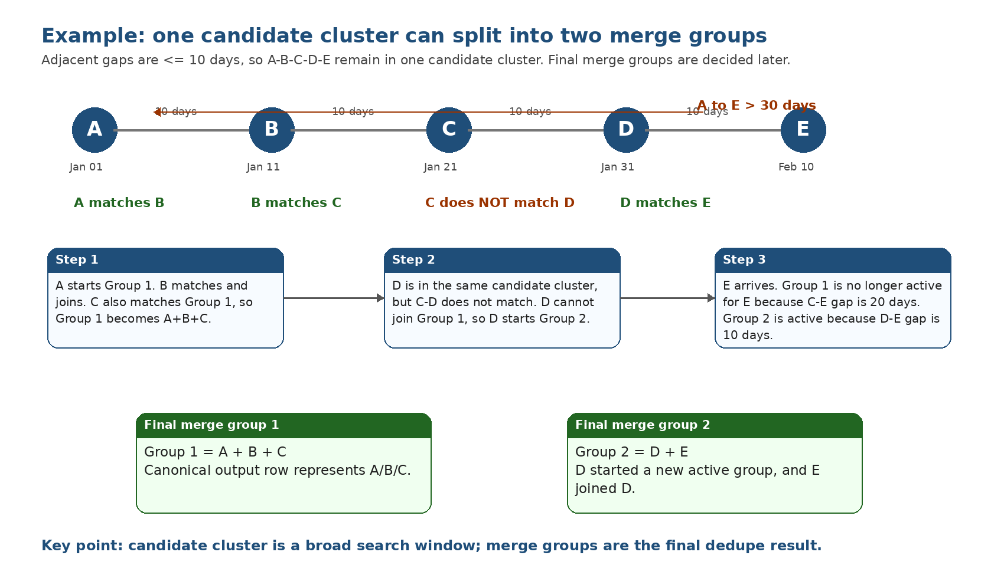
Figure 5. A-B-C-D-E example: one candidate cluster can produce two merge groups.
Step 1: Candidate cluster creation sees only adjacent gaps and candidate key. Because A-B, B-C, C-D, and D-E are each <= 10 days, all five rows remain in the same candidate cluster.
Step 2: Merge assignment processes rows in date order. A starts Group 1. B matches A and joins Group 1. C matches the active Group 1 representative and joins Group 1. Group 1 becomes A+B+C.
Step 3: D arrives. Group 1 is still within the latest-gap/date checks, but C-D does not match. D does not join Group 1. D starts Group 2 and remains active for future rows.
Step 4: E arrives. E is in the same candidate cluster, but final merge checks active groups. Group 1 latest row is C. Since C-E is 20 days in this example, Group 1 is pruned before scoring E. Group 2 latest row is D, and D-E gap is 10 days, so E can compare with D. Because D matches E, E joins Group 2.
Final result:
Group 1 = A + B + C
Group 2 = D + E
The 30-day A-E span does not split the candidate cluster. Candidate clustering uses rolling adjacent gaps. The 30-day span is applied later at merge-group assignment time. In this example, E does not join Group 1 mainly because Group 1 is no longer active for E due to the 10-day latest-gap pruning; even if it were active, the 30-day span would also prevent a group from growing beyond the allowed max span.

6.9 Candidate cluster versus merge group
Candidate cluster is a broad search boundary. Merge group is the final dedupe result. One candidate cluster can produce one merge group, multiple merge groups, review rows, and keep-separate rows.
Candidate cluster:
A B C D E
Final merge groups:
A+B+C D+E

7. Additional Note: Complete JD Comparison Instead of 3,500-Character Sample
The current implementation compares full cleaned JD when the shorter side is <= 3,500 characters. When the shorter side is longer than 3,500 characters, it uses a stratified shorter-side sample. The longer side remains the full cleaned JD.
If feasible at production scale, the team can evaluate replacing the 3,500-character shorter-side sample with complete-JD token comparison. This may reduce false negatives where important matching tokens fall outside the stratified sample. The tradeoff is runtime, memory, and Snowflake cost for large candidate clusters.
- Option 1: full-JD token comparison in SQL arrays.
- Option 2: pre-tokenized job-token table and containment joins.
- Option 3: Snowpark/Python full-token processing with checkpointing.
- Recommended validation: run current sampling and complete-JD comparison on the same Q1 sample and compare bucket movement, runtime, cost, and manual QA quality.

8. Additional Note: Large-cluster pair-scoring limits
Large-cluster pair-scoring limits: The notebook currently caps bulk pair diagnostics using MAX_ROWS_PER_PAIR_SCORING_CLUSTER = 150 and MAX_PAIRS_PER_PAIR_SCORING_CLUSTER = 5000. These limits were added as execution-stability guardrails to prevent pair-count explosion during notebook execution. They are not business dedupe rules. In production, DE can evaluate increasing or removing these limits if the warehouse size, query design, and orchestration can safely process full pair diagnostics for large candidate clusters. If removed, DE should monitor runtime, cost, intermediate table size, skipped-diagnostic volume, review-bucket movement, and false-positive/false-negative merge behavior.

9. Handoff Summary
This notebook should be handed over as a Q1 2025 parent-title dedup architecture. The flow is: candidate key first, rolling 10-day candidate windows second, JD similarity plus 10-day/30-day merge guardrails third, and lineage-preserving canonical output with QA and review buckets last.
The most important conceptual point is that candidate clusters are not final merge groups. Candidate clusters intentionally over-collect possible duplicate rows. The active-group logic later splits that search space into the correct final merge groups based on date eligibility and JD similarity.

